## Banjo Mandolin Guitar Festival, Cambridge

## 05-07 April 2024

## Banjo Mandolin Guitar Festival, Cambridge

## 05-07 April 2024

## Banjo Mandolin Guitar Festival, Cambridge

## 05-07 April 2024

## Banjo Mandolin Guitar Festival, Cambridge

## 05-07 April 2024

## Banjo Mandolin Guitar Festival, Cambridge

## 05-07 April 2024

## Banjo Mandolin Guitar Festival, Cambridge

## 05-07 April 2024

## Banjo Mandolin Guitar Festival, Cambridge

## 05-07 April 2024

## Banjo Mandolin Guitar Festival, Cambridge

## 05-07 April 2024

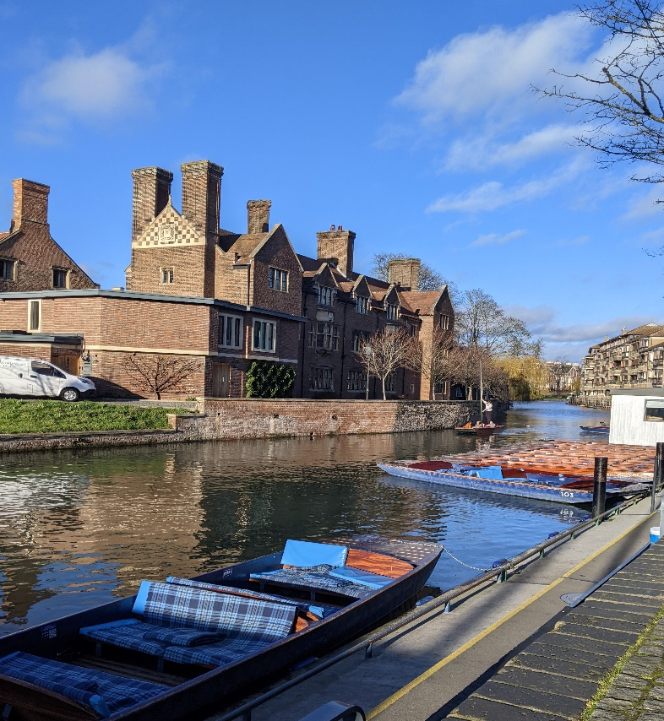

# Weekend Programme

Churchill College

Storey’s Way

Cambridge

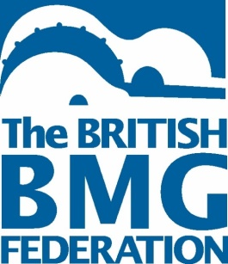CB3 0DS

In association with the Moonlight Mandolin Orchestra

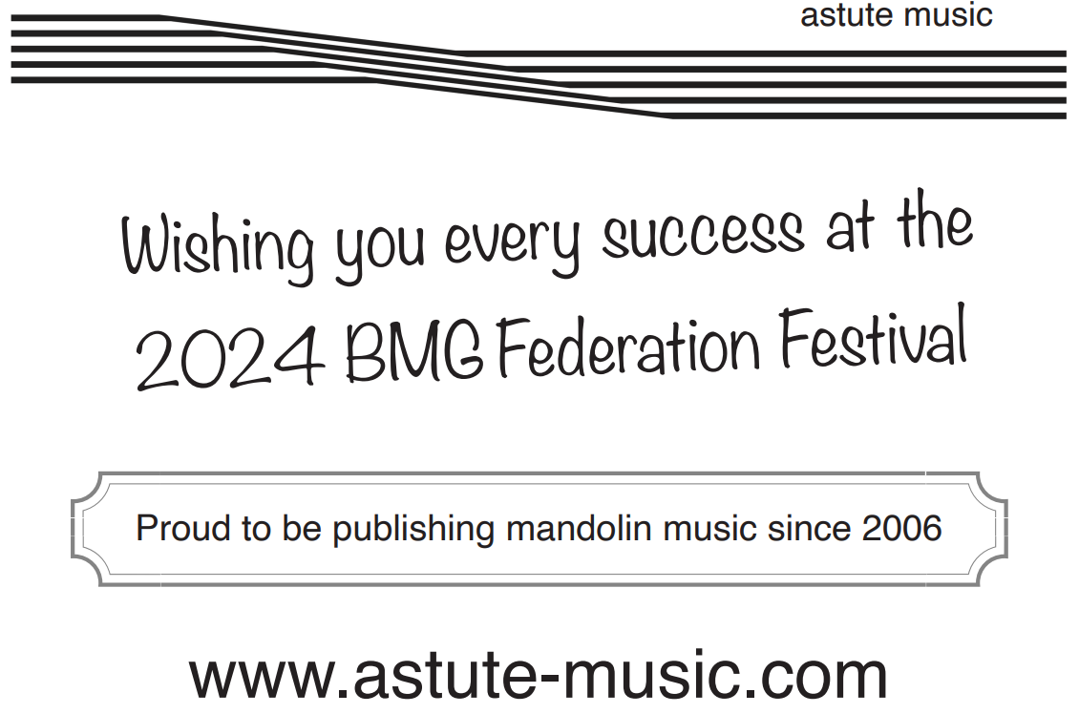

Contents

The British BMG Federation 4  
Welcome to Cambridge! 5   
Festival Weekend Timetable at a Glance 6  
Friday Night Concert 7.30pm 7   
Map 10   
Timetable for contests Sat April 6th 2024 11   
Wolfson Hall Saturday Contests and Performances 14  
Judging Criteria for Contests 15  
Workshops - Saturday Afternoon Workshops 16 Saturday afternoon concert 5.15pm Wolfson Hall 17   
BMG Federation AGM 17 Contests in the Buttery 8.00pm 18 Presentation of the Awards 18   
Ceilidh 19   
Sunday Morning Workshops 20   
Concert with two orchestras Wolfson Hall 11.45am 20   
Festival Orchestra Buttery at 1.30pm 21   
Concert Finale Wolfson Hall 3.30pm 22

# The BMG Federation would like to thank our sponsors for their generosity in supporting our Festival.

Astute Music  
 John Alvey Turner  
 Lute Society  
 Schott Music  
 Victoria College Exams

Special thanks also go to Moonlight Mandolin Orchestra for hosting this event and for their work and organisation to ensure the success   
of this weekend.

THE BRITISH BMG FEDERATION

The British BMG Federation is an organisation that celebrates all things fretted, with the aim of promoting the performance and learning of banjos, mandolins and guitars by creating educational opportunities such as workshops and courses for players of all ages to develop and improve skills on their chosen instruments.

This Festival is an event held biennially at different locations around the United Kingdom. The 2024 Festival is being held in Cambridge for the first time. We trust that you will all have an enjoyable weekend of music-making, listening to professionals and keen amateurs too and learning through a range of workshops. Above all, we hope you will enjoy the company of a wide range of other musicians from all over the country and much further afield.

The BMG Federation Summer School is an annual residential event that this year is occurring in June at Higham Hall, Cumbria where three different classes meet to focus on fretted instrument playing.

The Federation produces quarterly newsletters with news, reviews, features, music and a diary of events. For information on becoming a member, please contact membership secretary Martyn Workman via email at [bmgfederation@gmail.com](mailto:bmgfederation@gmail.com)

Learn more about the Federation and its work at [www.bbmg.org.uk](http://www.bbmg.org.uk)

**Like us on Facebook /BMG Federation**

**Follow us on X @BMGfederation**

# WELCOME TO CAMBRIDGE!

It is with great pleasure that the Moonlight Mandolin Orchestra welcomes all BMG Festival visitors to Cambridge this April.

This is the first time we have had the honour of hosting the BMG Festival, and we are very excited about the programme and format of this unique biennial event. We hope that everyone participating, whether as performers, teachers, players or adjudicators, will find the experience rewarding, and that this great reunion of fretted instrument players will give us all many new insights and inspirations.

The Moonlight Mandolin Orchestra has always had teamwork at its heart. We started life in around 2002 as a group of three or four pupils who attended a mandolin evening class run by Hugh Boyde for Cambridgeshire Music. Gradually a solid core of keen and committed players emerged, and in 2004 we decided to stop being a teaching group and focus on rehearsing for performances instead.

We look forward to meeting our good friends, old and new, at this year’s BMG Festival in Churchill College, and to helping our guests in any way we can.

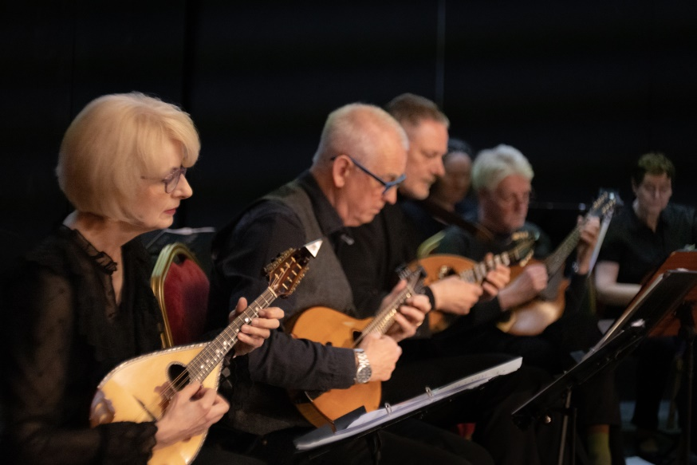

# Festival Weekend Timetable at a Glance

**Friday** from 3pm Residents arrive and check in  
2.00pm BFO rehearsal  
6.00pm Evening meal   
7.30pm Concert from BFO and the Duo Oltremare from Italy  
 (Raffaele la Ragione and Andrea de Vitis) followed  
 by socialising/informal music-making in the Buttery

**Saturday**

From 9:00am Contests: 3 separate rooms; individual / group contests finish by11.20am

11.30-12.30 Concert  
Bristol Mandolin and Guitar Ensemble   
Phoenix Mandolins

12.30pm Lunch

1.30pm Orchestra Contest 19: Midlands Fretted Orchestra and Mango Youth Orchestra

2.45–5.00pm Workshops

5.15pm Concert: Elias Sibley and Florence Petit

Iain Lennon

6.15pm British BMG Federation AGM

From 6.30pm Evening meal

8.00pm Contests 22/23

8.45pm Presentation of Awards

9.30pm Ceilidh: Presentation of Award for Contests 22 & 23 during a break in the Ceilidh

**Sunday**   
9.15am Workshops  
11.45am Concert   
 Da Capo Alba,   
 Moonlight Mandolin Orchestra  
12.45pm Lunch  
1.45pm Festival Orchestra   
3.30pm Concert   
 Fretful Federation Mandolin Orchestra   
 Samrat Majumder  
5.00pm Festival closes

Friday Night Concert 7.30pm  
British Fretted Orchestra  
Duo Oltremare

**British Fretted Orchestra**

Led by their conductor, Michael Graham, the BFO will present the following pieces.

Richard Charlton: Dances for the Mandolin and the Moon

William Boyce: Symphony No. 4

1. Allegro 2. Vivace ma non troppo 3. Gavot: Allegro

Nigel Gatherer: A Nathaniel Gow Suite

Maurice Ravel: Pavane pour une infante défunte

Daniëlle de Rover: FusionEm

Many thanks to the composers and arrangers who have generously given permission for these pieces to be performed.

**Duo Oltremare**

The second part of the concert will consist of a concert by Duo Oltremare – mandolinist Raffaele Le Ragione and his guitarist partner, Andrea de Vitis

They will play music by Scarlatti, Soler, Albeniz, De Falla and Paliotti. **Domenico Scarlatti** (Napoli, 1685 – Madrid, 1757)  
*Sonata K91*  
Grave / Allegro / Grave / Allegro

*Sonata K141*  
Allegro  
  
**Antonio Soler** (Olot, 1729 – San Lorenzo de El Escorial, 1783)  
*Sonata op.18 in A Minor*  
Allegro

**Domenico Scarlatti**  
*Sonata K89*  
Allegro / Grave / Allegro

**Isaac Albeniz**(Camprodon, 1860 – Cambo-les-Bains, 1909)  
*Suite Ancienne* no.3  
Minuetto / Gavotta

**Manuel De Falla** (Cadiz, 1876 – Alta Gracia, 1946)  
*7 canciones populares españolas*  
I. El Paño Moruno / II. Seguidilla Murciana / III. Asturiana  
IV. Jota / V. Nana / VI. Canción / VII. Polo

**Antonello Paliotti** (Napoli, 1963)  
*Variazioni sul basso di tarantella*

Born in Naples in 1685 and embarking on his musical career in Rome under the guidance of his father Alessandro, **Domenico Scarlatti** arrived in Lisbon in 1719 during a period of great economic development for Portugal. He became ‘the King's composer’ at the Court of João V – a role which also included teaching João’s daughter, Maria Bárbara, who was an excellent harpsichord player.

Some ten years later, Princess Maria Bárbara married Ferdinand of Asturias, becoming Queen of Spain. However, she was obliged to forget her past when she moved to Spain, and had to leave behind everything that reminded her of her family roots. The only thing she was allowed to take with her was... her beloved music master. This is how Domenico arrived first in Seville and then in Madrid. These travels offered Scarlatti new inspiration and numerous ideas: in his music, in fact, we can often find influences from the Iberian popular tradition and even idiomatic evocations of the stringed instruments that were popular in Spain and Portugal in the era.

Through our instruments, we follow this musical journey between Naples and Spain, focusing on the intimate connection between folkloric influences and classical forms.

The starting-point is the stylistic affinity between the sonatas of Domenico Scarlatti and those of **Antonio Soler** (himself a pupil of Scarlatti’s in Madrid).

Our journey continues in Spain through the *Suite ancienne* by **Isaac Albéniz**. This typically Baroque musical form has been elaborated by Albéniz in an intimate key.

The neo-baroque language of the *Suite ancienne* represents a bridge towards a stronger influence on the part of popular music, filtered through the Impressionist harmonies of the composer **Manuel de Falla**, whose suite of songs *Siete canciones populares españolas* brings us nearer to modern times.

At the end of this musical journey, we return to Naples with a different type of folklore in the form of **Antonello Paliotti's** *Variazioni sul basso di tarantella*, a set of variations elaborated on the ancient bass of ‘*Guarracino’*. This final piece shows us how popular traditions and folkloric influences can bring together worlds that seem very far-flung in time and space.

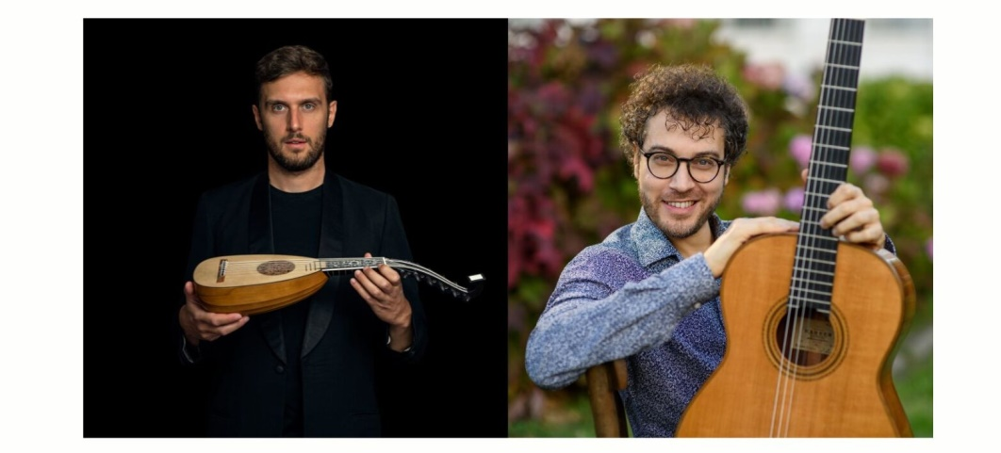

# Map of rooms



# Timetable for contests Sat April 6th 2024

|  |  |  |  |
| --- | --- | --- | --- |
|  | Clubroom | Jock Colville Room | Recital Room |
|  | 2 Merit Challenge Cup | 5 Federation Challenge Cup | 25 Frances Taylor Cup for Baroque |
| 9.00 | **Zak Roberts**  Suite Montebello: II Tisu - Julio Cesar Oliva | **John Burr**  Meditation by Massenet | **EMGO Bar**  Will the Sun Forget to Streak – Aria by GF Handel |
| 9.05 | **Mary Crawford** Amarillo by Neil Sedaka/Howard Greenfield Accompanied by Duncan Harbison | **Elisabeth Michel** Mandoline by Francis Thomé | **Davies Duo**  Allegro from Concerto in D maj by JS Bach |
| 9.10 | **Erin Simpson** Mandolin Groove – Anon |  | **Therese & Martyn Workman**  Sonata in Dm by Domenico Scarlatti |
| 9.15 | **Callum Young** Sunburst by Andrew York | **Tim Bainbridge** Courante from Bach Suite No1 in G |  |
|  | 12 Grett Scott Challenge Cup |  | 16 Clifford Essex Challenge Cup |
| 9.20 | **Nick Gravestock**  Her Rosie Cheeks by Thomas Campion | **Andrew Burnside** Arrabbiosa by B Persichini | **Moonshot Mandolin Ensemble**  Rio de Janeiro Suite, Movement 5, Samba, by Jürg Kindle (written for mandolin orchestra, 2016) |
| 9.25 | **Richard Woolley** Jingle Bell Rock – Bobby Helms arr. R Woolley |  | **Bright'n'Early**  Sonata in B minor K87 Domenico Scarlatti |
| 9.30 |  |  | **Da Capo Guitar Quartet** Mishima Movement 1 by Philip Glass |
|  | 13 H Lambert Veterans Cup | 7 Federation Cup |  |
| 9.35 | **Simon Handley** Pavane by Francisco Tárrega | **John Davey**  Andante for 2 Mandolins RV532 (arr. J Davey) |  |
| 9.40 | **John Burr**  *Por una Cabeza* by Carlos Gardel |  | **Shearing Quartet** Entrancement by Richard Shearing |
|  | Clubroom | Jock Colville Room | Recital Room |
| 9.45 | **Elisabeth Michel** Andalusia by Angy Palumbo or Eucalypts by Graham Powning | **Stelios Christodoulou** Rondeau by Rudolf Straube | **The Narrowboat Quartet**  Quartetto by Munier |
| 9.50 |  | **Ryan Martin**  Etude No. 11 by Heitor Villa-Lobos |  |
|  |  |  |  |
| 9.55 | **Andrew Burnside**  El Duende by JA Zambrano | **Simon Handley**  Prelude No. 3 by Heitor Villa-Lobos |  |
|  |  | 9 John Alvey Turner Cup | 15 SF Waddington Cup |
| 10.00 | **Nick Gravestock** Fantasia 3 for Vihuela by Luis Milan | **Tim Bainbridge**  Harvest Home + variation(s) (Trad.) | **Leonard Trio**  Let’s Take the Flip Side by Cees Hartog |
|  | 11 Marion Marlow Cup |  |  |
| 10.05 | **Elizabeth O'Beirne-Ranelagh**  Technique on Eight Strings no. VIII by Gertrude Troster | **Simon James**  Bunch of Keys by Emile Grimshaw, accompanied by John Davey |  |
|  |  |  |  |
| 10.10 | **Nick Gravestock**  Go From My Window' Anon from Folger Dowland Manuscript | **Paul Goodall** Summertime by George Gershwin | **John Burr**  New Rag by Scott Joplin |
| 10.15 | **Andrew Burnside** Prelude by GF Handel |  | **The Henbury Trio**  Sonata IV 1 Gratioso by William Boyce |
| 10.20 |  |  | **The TMS Trio**  Jesu, Joy of Man’s Desiring by JS Bach |
| 10.25 |  |  |  |
|  |  | 10 Chris Sands Ragtime Banjo Trophy | 26 LGMA Veterans Trophy |
| 10.30 | **John Davey**  The Entertainer by Scott Joplin | **Adam Bell**  Maple Leaf Rag by Scott Joplin | **Shearing Quartet**  Maple Leaf Rag by Scott Joplin |
|  | Clubroom | Jock Colville Room | Recital Room |
| 10.40 |  | **Tim Bainbridge**  Dill Pickle Rag by Charles L Johnson |  |
|  | 14 Clifford Essex London Cup |  |  |
| 10.45 | **Richard Breeze** **& Collette Cross**  Bolero by Raffaele Calace | 4a Stephens Churchill Youth Ensemble Trophy |  |
| 10.50 | **Elizabeth O'Beirne-Ranelagh and Stelios Christodoulou**  *Estudio* #6, Fernando Sor | **Mango Ensemble** | **John Burr, John Davey & Simon James**  First Class |
| 10.55 | **Davies Duo (Richard Shearing & Gethin Davies)**  ‘Bambuco’ by Alfonso Montes | 3­ Sid Smith Memorial Cup | 24 Lute Society Renaissance and Early Music Trophy |
| 11.00 | **Andrew Burnside & Richard Lathe** Excerpts from *Suite Venezolana* by J A Zambrano | **Paul Goodall**  Dream a Little Dream of Me Andre Schwandt |  |
| 11.05 | **Zak & Ryan**  Invitation by Sergio Assad from the Tummer Garden Suite |  | **Bright'n'Early**  ‘*Io Mi Son Giovinetta*’ Domenico Ferrabosco |
| 11.10 | **Flossie Hay & Erin Simpson**  Sonata IV by Giovanni Fouchetti |  |  |
| 11.15 | **Simon James &** **John Davey**  Pineapple Rag by Scott Joplin |  | **Shearing Quartet** *Ricercare* by Andrea Gabrieli |
|  |  |  |  |

# 

# Wolfson Hall Saturday Contests and Performances

|  |  |
| --- | --- |
|  | 21 Fenton Weill Challenge Cup for Folk |
| 10.20 | **Tim Bainbridge Folk Set** |
| 10.35 | **Edinburgh Mandolin and Folk**  Lindisfarne by Matt Seattle, Moray’s Frolick Trad by Neil Gow arr. N Gatherer |
| 10.50 | **Erin Simpson and Shona Clyde**  Monaghan Jig composer unknown **(Craig)** |
|  | 17 Francis Day and Hunter Trophy |
| 11.00 | **MFO Banjo Racketeers** Danielle Saxon Reeves, Chatanooga Choo Choo Players |
| 11.10 | **Phoenix Mandolins** Fugues Just For Fun 4 & 5 by Andy Boden |
|  | Orchestras playing with Feedback |
| 11.30 | **Bristol Mandolin & Guitar Ensemble**  *Addio del Passato* by Giuseppe Verdi arr. Knud Stuwe, Theme from Jean de Florette by Jean Claude Petit, James Bond |
| 12.00 | **Phoenix Mandolin Orchestra** Fugues Just For Fun 4 & 5 by Andy Boden Reverie by Eileen Pakenham La Vita e Bella by Nicola Piovani arr. Tomas Gabucci |
|  | 19 Senior Orchestra Contest |
| 1.30 | **Midlands Fretted Orchestra** Muppets Theme by Jim Henson / Sam Pottle, Ghostbusters by Ray Parker Jr, Pirates of the Caribbean by Hans Zimmer, Gabriel’s Oboe by Ennio Morrecone, Minor Swing by Django Rheinhardt / Stéphane Grappelli, Wallace and Gromit by Julian Nott |
| 2.00 | **Mango Youth Orchestra** The Last Of Us by Gustavo Santaolalla, Catapulting Penguins by Barbara Pommerenke-Steel, Man I Feel Like A Woman by Shania Twain, He's a Pirate by Klaus Badelt and Hans Zimmer |

# Judging Criteria for Contests

**Main Contests**   
Complexity of piece 10%   
General musicianship 40% (includes tuning, tone, technical ability and accuracy)   
Interpretation 40% (includes dynamics, phrasing and expression)  
Overall Presentation 5%  
Adjudicators’ discretion 5%

**Composition Contest (20)**   
Originality of ideas 35%   
Development of ideas 20%   
Structure & development of piece 20%  
Guidelines towards interpretation 10%  
Suitability for the instruments 10%  
Adjudicators’ discretion 5%

**Folk Contest (21)**Complexity of piece 10%   
General musicianship 40% (includes tuning and tone)   
Interpretation 40% (includes dynamics and expression)   
Overall presentation 5%  
Adjudicators’ discretion 5%

**Fun Contest (22)**Complexity of piece 10%  
General musicianship 40% (includes tuning and tone)   
Fun element 40% (includes dynamics and expression)   
Overall presentation 5%  
Adjudicators’ discretion 5%

The BMG Federation Committee would like to thank our adjudicators on your behalf. With particular thanks to Frances Taylor, our Chief Adjudicator, and her team of Anna Langley, Hugh Boyde, Rob Garcia, Iain Lennon, Craig Moran, Michelle Nelson, Colin Tribe, Knude Stuwe, Michael Graham, Elias Sibley, Florence Petit and Raffaele la Ragione.

# Workshops

There are two blocks of workshops – Saturday afternoon and Sunday morning. Please check where the workshops you have booked are to be found. There will be plenty of signs around the campus to help you.

|  |  |  |  |  |  |
| --- | --- | --- | --- | --- | --- |
| **Saturday afternoon** | | |  |  |  |
| 2.45-3.45pm | A1  Banjo workshop  Elias Sibley  **Tizard Room** | A2  Improving your mandolin technique  Iain Lennon  **Club Room** | A3  Eileen Pakenham  (duo, trio, solo, ensemble)  Barbara Pommerenke Steel  **Bevin Room** | A4  Latin American folk music  Margarita Salazar  **Jock Colville Hall** | A5  Mandolin workshop  Raffaele la Ragione  **Recital Room** |
|  |  |  |  |  |
| 4.00pm-5.00pm | B1  New syllabus for Mandolin  Hugh Boyde  (& Iain Lennon, Barbara Pommerenke-Steel)  **Tizard Room** | B2  Mandolin restoration / construction  Chris Egerton  **Club Room** |  | B5  Guitar workshop  Andrea De Vitis  **Bevin Room** |
|  |  |  |  |  |  |

# Saturday afternoon concert 5.15pm Wolfson Hall

Elias Sibley and Florence Petit

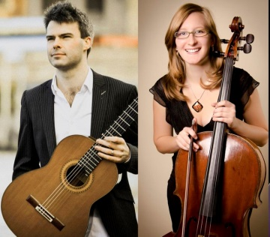  
For this brief concert, Elias will play some banjo music and also switch to his guitar and play with Florence Petit on cello. The combination of guitar and cello provides a rich fusion of expression and spirit to their compelling performance.

Iain Lennon

The second part of this concert will centre on Iain’s performance of a range of music demonstrating the range of music recently written for the mandolin.

# BMG Federation AGM

This will be a short but important meeting for all BMG Federation members. It will follow on from the concert. Please stay and have your say.

|  |  |
| --- | --- |
|  | 23 VCM Ukulele Cup |
| 8.00pm | **MFO Ukes**  Chatanooga Choo Choo by Harry Warren & Mack Gordon (arr. R Woolley) |
|  | 22 BMG Federation Fun Trophy |
| 8.10pm | **Midnight Mavericks**  Are You Lonesome Tonight by R Turk & L Handman |
| 8.20pm | **Woodentops**  Funky Moped by Jasper Carrott |
| 8.30pm | **Three Kings and The Camel**  'Tequila' – The Champs |

# Contests in the Buttery 8.00pm

# Presentation of the Awards

This will take place on Saturday evening in the Buttery, right next to the bar, where the rest of the evening’s entertainment will take place.

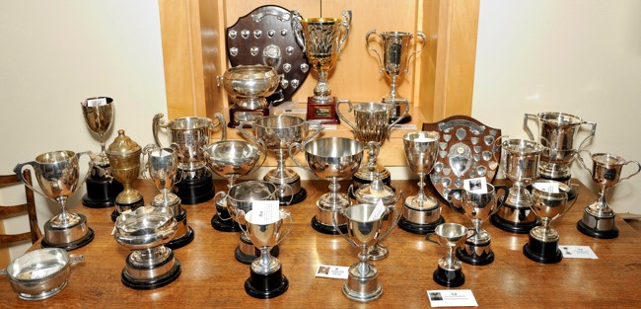

# 

# Ceilidh

The Cambridge Phoenix Ceilidh Band will conclude our evening with a great set of dances to get us all on our feet.

**The Cambridge Phoenix Ceilidh Band**

**Contact Rod Halls on 01954 252702**

The bar will stay open until midnight, so enjoy a sociable evening and dance the night away.

# Sunday Morning Workshops

|  |  |  |  |  |  |
| --- | --- | --- | --- | --- | --- |
|  |  |  |  |  |  |
| **Sunday morning** | | |  |  |  |
| 9.15  am-10.15am | C1  The art of Imitation  Iain Lennon  **Club Room** | C2  Banjo orchestra  Danielle Saxon Reeves  **Bevin Room** | C3  Baroque Mandolin Orchestra  Frances Taylor  **Jock Colville Hall** | C4  Guitar  Masterclass  Andrea de Vitis and Barbara Pommerenke-Steel  **Tizard Room** | C5  Understanding modes through folk tunes  Rob Garcia  **Recital Room** |
|  |  |  |  |
| 10.30am-11.30am | D1 Ladies' Mandolin and Guitar Bands in Late Victorian England by Paul Sparks and John Mackenzie  **Club Room** | D4  Bluegrass workshop  Iain Lennon  **Recital Room** | D5  Ukulele workshop  Colin Tribe  **Tizard Room** |

# Concert with two orchestras Wolfson Hall 11.45am

|  |  |
| --- | --- |
|  | **Orchestras Playing with Feedback** |
| 11.45am | **Da Capo Alba**  *Les Misérables* Medley by Claude-Michel Schönberg Lion King Medley by Hans Zimmer |
|  |  |
| 12.15pm | **The Moonlight Mandolin Orchestra**  *Rue de Montmartre* by Michelle Nelson with clarinet soloist Trevor Barlow, Youkali by Kurt Weill arr. Hugh Boyde, *El Noy de la Mare* (Catalan traditional) arr. Hugh Boyde |

# Festival Orchestra Buttery at 1.30pm

Those of us who were at Edinburgh will remember the enormous pleasure that we got from the Festival Orchestra in 2022, led by Knud Stuwe, playing the Allegretto from Beethoven’s 7th Symphony. It was a fantastic opportunity to have so many of our instruments all in the same room!

We plan to do this again, this time led by Barbara Pommerenke-Steel and focused on ‘Music’ by John Miles.



We are looking forward to making some exciting music again this time!

# Concert Finale Wolfson Hall 3.30pm

The concert will start with a performance by Fretful Federation Mandolin Orchestra and Friends performing The Shadow of Golden Dream by David Sutton-Anderson. It is inspired by writings of Hermann Hesse.

**Movement I**   
We turn passionately, exhausted by day,  
To the ambrosia, the night of your music,  
Whose fanning wing casts us into  
A shadow of golden dream. *Ode an Hὂlderlin*  
**Movement 2**Insect dance in evening radiance. *Feierliche Abendmusik***Movement 3**Blown by the storm of south wind  
I fly unwearied. *Im Grase Liegend*

# 

# Samrat Majumder

John Dowland: Präludium & Fantasia No. 7 (P. 98, 1)

Johann Sebastian Bach: Prelude, Fugue and Allegro (BWV 998)

Augustín Barrios Mangoré: Mazurka Appassionata & País de Abanico

4 Songs from Eastern Cultures:

The Moon Represents My Heart (月亮代表我的心) – Weng Ching-hsi (arr. R. Dyens)

Ye Banks and Braes, Phule Phule Dole Dole – Robert Burns, Rabindranath Tagore (arr. S. Majumder)

Hana wa Saku (花は咲く) – Yoko Kanno (arr. Y. Koseki)

Auld Lang Syne, Purano Sei Diner Lothar – Robert Burns, Rabindranath Tagore (arr. S. Majumder)

